### [**05 -**](https://www.rajalakshmicolleges.net/moodle/course/view.php?id=84#section-5) **Strings in Python**

**Ex. No. : 5.1 Date: 17.04.24**

**Register No.: 231801126 Name: PRAGADISHWARAN S**

**String characters balance Test**

Write a program to check if two strings are balanced. For example, strings s1 and s2 are balanced if all the characters in the s1 are present in s2. The character’s position doesn’t matter. If balanced display as "true" ,otherwise "false".

**For example:**

| **Input** | **Result** |
| --- | --- |
| Yn  PYnative | True |

**Program:**

a=input()

b=input()

if a in b or b in a:

print("True")

else:

print("False")

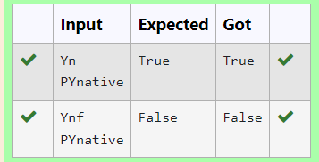

**Ex. No. : 5.2 Date: 17.04.24**

**Register No.: 231801126 Name: PRAGADISHWARAN S**

**Decompress the String**

Assume that the given string has enough memory. Don't use any extra space(IN-PLACE)

Sample Input 1

a2b4c6

Sample Output 1

aabbbbcccccc

**Program:**

s=input()

r=""

i=0

while i< len(s):

char=s[i]

i+=1

num=""

while i<len(s) and s[i].isdigit():

num+=s[i]

i+=1

r+=char*int(num)

print(r)

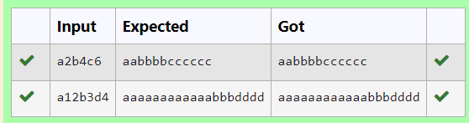

**Ex. No. : 5.3 Date: 17.04.24**

**Register No.: 231801126 Name: PRAGADISHWARAN S**

**First N Common Chars**

Two string values S1, S2 are passed as the input. The program must print first N characters present in S1 which are also present in S2.

Input Format:

The first line contains S1.

The second line contains S2.

The third line contains N.

Output Format:

The first line contains the N characters present in S1 which are also present in S2.

Boundary Conditions:

2 <= N <= 10

2 <= Length of S1, S2 <= 1000

Example Input/Output 1:

Input:

abcbde

cdefghbb

3

Output:

bcd

Note:

b occurs twice in common but must be printed only once.

**Program:**

a=input()

b=input()

n=int(input())

bset=set(b)

cc=[]

c=0

for i in a:

if i in bset and i not in cc:

cc.append(i)

c=c+1

if(c==n):

break

s=''.join(cc)

print(s)

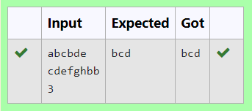

**Ex. No. : 5.4 Date: 17.04.24**

**Register No.: 231801126 Name: PRAGADISHWARAN S**

**Username Domain Extension**

Given a string S which is of the format USERNAME@DOMAIN.EXTENSION, the program must print the EXTENSION, DOMAIN, USERNAME in the reverse order.

**Input Format**:

The first line contains S.

**Output Format**:

The first line contains EXTENSION.

The second line contains DOMAIN.

The third line contains USERNAME.

**Boundary Condition:**

1 <= Length of S <= 100

Example Input/Output 1:

**Input**:

vijayakumar.r@rajalakshmi.edu.in

**Output**:

edu.in

rajalakshmi

vijayakumar.r

**Program:**

s=input()

at=s.index('@')

dot=s.index('.')

username=s[:at]

domain=s[at+1:dot]

exten=s[dot+1:]

print(exten)

print(domain)

print(username)

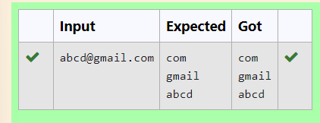

**Ex. No. : 5.5 Date: 17.04.24**

**Register No.: 231801126 Name: PRAGADISHWARAN S**

**Count Chars**

Write a python program to count all letters, digits, and special symbols respectively from a given string

**For example:**

| **Input** | **Result** |
| --- | --- |
| rec@123 | 3  3  1 |

**Program:**

s=input()

a,b,c=0,0,0

for i in s:

if(i.isalpha()):

a+=1

elif(i.isalnum()):

b+=1

else:

c+=1

print(a,b,c,sep="\n")

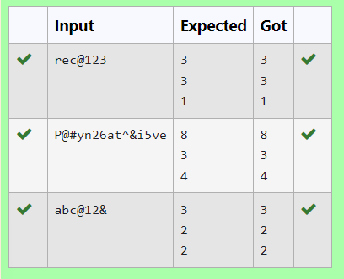

**Ex. No. : 5.6 Date: 17.04.24**

**Register No.: 231801126 Name: PRAGADISHWARAN S**

**Reverse String**

Reverse a string without affecting special characters. Given a string S, containing special characters and all the alphabets, reverse the string without affecting the positions of the special characters.

Input:

A&B

Output:

B&A

Explanation: As we ignore '&' and

As we ignore '&' and then reverse, so answer is "B&A".

For example:

Input Result

A&x#

x&A#

**Program:**

s=input()

l=[]

for i in s:

if(i.isalpha()):

l.append(i)

l.reverse()

r=''

index=0

for i in s:

if(i.isalpha()):

r+=l[index]

index+=1

else:

r+=i

print(r)

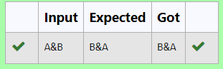

**Ex. No. : 5.7 Date: 17.04.24**

**Register No.: 231801126 Name: PRAGADISHWARAN S**

**Longest Word**

Write a python to read a sentence and print its longest word and its length

**For example:**

| **Input** | **Result** |
| --- | --- |
| This is a sample text to test | sample  6 |

**Program:**

sen=input()

words=sen.split()

l=""

maxi=0

for word in words:

if(len(word)>maxi):

l=word

maxi=len(word)

print(l,maxi,sep="\n")

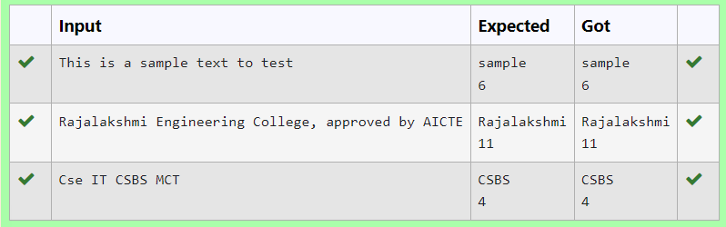

**Ex. No. : 5.8 Date: 17.04.24**

**Register No.: 231801126 Name: PRAGADISHWARAN S**

**Remove Palindrome Words**

String should contain only the words are not palindrome.

Sample Input 1

Malayalam is my mother tongue

Sample Output 1

is my mother tongue

**Program:**

s=input()

words=s.split()

x=''

for word in words:

word=word.lower()

if (word!=word[::-1]):

print(word,end=" ")

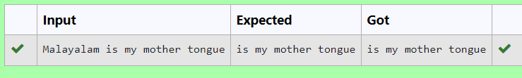

**Ex. No. : 5.9 Date: 17.04.24**

**Register No.: 231801126 Name: PRAGADISHWARAN S**

**Remove Characters**

Given two Strings s1 and s2, remove all the characters from s1 which is present in s2.

Constraints

1<= string length <= 200

Sample Input 1

experience

enc

Sample Output 1

xpri

**Program:**

s1=input()

s2=input()

x=''.join(char for char in s1 if char not in s2)

print(x)

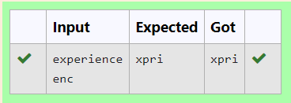

**Ex. No. : 5.10 Date: 17.04.24**

**Register No.: 231801126 Name: PRAGADISHWARAN S**

**Unique Names**

In this exercise, you will create a program that reads words from the user until the user enters a blank line. After the user enters a blank line your program should display each word entered by the user exactly once. The words should be displayed in the same order that they were first entered. For example, if the user enters:

**Input:**

first

second

first

third

second

then your program should display:

**Output:**

first

second

third

**Program:**

l=[]

while(True):

a=input()

if a!=" ":

l.append(a)

else:

break

l=dict.fromkeys(l)

for i in l:

print(i)

